Saint Petersburg State University
is pleased to invite you to
XX International Student Law Conference
iSLaCo’ 2020
«Law: New&Now»
3 - 4 April 2020
The conference is planned to have the following sections:
- Complex branches of law phenomenon: shaken, not stirred.
Moderators: Vasilyev I. A., Diveeva N. I.
- Modern criminalization: how criminal law meets the challenges of fast-moving world.
Moderator: Shatikhina N. S.
- Five years of the Law of obligations Reform: expectations and results.
Moderator: Pavlov A. A.
- Legal Tech: the Present and the Future of Jurisprudence.
Moderators: Arkhipov V. V., Gracheva A. V.
- Administrative Offence Law reform: what to expect from the new Code.
Moderator: Dmitrikova E. A.
- Disposal actions in the civil procedure.
Moderator: Volodarski D. B.
- Comparative Law in the modern era
Moderator: Belov S. A.
Topics of master class of leading jurists and the cultural program will be published later in the official social network of the conference.
Winner’s abstracts (in each section will be a one winner) will be published in Vox Juris Journal.
The working languages of the conference: Russian, English.
I. Description of sections
1. Complex branches of law phenomenon: shaken, not stirred.
Sport law, medical law, environmental law, informational law… They all are the examples of complex branches. Within this section is intended to discuss work on sports and medical law. But it doesn’t mean any restrictions for participants to choose another complex branch in order to write their works. Examples of sports and medical law can be found in Annex II to this information latter.
2. Modern criminalization: how criminal law meets the challenges of fast-moving world.
In conditions of constant technical progress and complication of social relations, criminal law has to react quickly to changing world. Drones, digital currency, the achievements of transplantology, bioethics and other signs of time – and related rights violations. Frequently before «the new» is evaluated in other branches of law, the socially dangerous acts it creates and ways and means of their commission should be covered by the criminally-legal qualification. How does world science behave facing the new? How will it behave tomorrow? How does the practice cope with challenges of time? What trends and issues are on the way?
3. Five years of the Law of obligations Reform: expectations and results.
The main aim of the section isn’t only to discuss institutes and solutions, which appeared as a result of the Law of obligation reform, but also to analyze its practical implementation today.
4. Legal Tech: the Present and the Future of Jurisprudence.
Within this section is intended to discuss the following issues in the field of Legal Tech: LegalTech developments; GovTech; automation of legal activity, computational law; Legal Design in legal practice; Ethic and new technologies; Philosophy of technology and law; Legal regulation of artificial intelligence and big data; Digital skills for a lawyer: programming, working with open data, etc.
5. Administrative Offence Law reform: what to expect from the new Code.
Within the section is intended to discuss planned changes of the legislation on Administrative Offences Law: categories of offences and measures of responsibility, division of responsibility of the legal person and the employee, the mitigation of coercive measures in case of voluntary execution of a sentence, guarantees for the provision of qualified legal assistance, the development of the adversarial system in cases of administrative offenses.
6. Disposal actions in the civil procedure.
Civil procedure law is a mobile branch of Russian legislation, which has recently undergone another large-scale reform. New institutions and mechanisms in the procedure naturally affect the scope of rights of its participants, and any changes should be understood systematically and theoretically. What are the trends in the formation of the rights of participants in the civil procedure? How do these new trends change the face of the branch? What difficulties and challenges does the Russian and world science of civil procedure face?
7. Comparative Law in the modern era.
Comparative Law is one of the fundamental elements of the development of domestic legislation. Within this section, participants can conduct a comparative legal analysis of current problems of Russian legislation with the possibility of implementing foreign experience. Participants are not limited to choose law branch and the country with which the comparative analysis will be conducted.
II. Important dates
Opening of applications: 23 October 2019.
The application deadline for participant with abstracts: 27 January 2020.
The application deadline for audience members: 27 January 2020.
Attention! The deadline for application WILL NOT be extended.
Official dates of the conference: 3 and 4 April 2020.

III. How to apply for participation
- Decide as who (participant or audience member) you want to participant in the conference.
Attention! Only face-to-face participation is allowed.
- Fill out the form:
Registration for the conference (participants with abstracts):
https://forms.gle/8keqKwRiMVmJisRH8
Registration for the conference (audience members):
https://forms.gle/LuevffwCByz1E1Hh7
Attention! You need a Google account to complete the survey and submit your application. It can take some time to create an account. We recommend you to register in advance.
If you think you will need an official invitation, please indicate this when filling out the form. Otherwise, the Organizing Committee may not have time to issue it on time.
- After the Organizing Committee receives the application, you will receive an automatic notification, which you don’t need to respond. If you haven’t received a notification, please fill out the form again. If you don’t receive it again, please contact the Organizing Committee.
It’s allowed to write a work in co-authorship, but not more than two co-authors for one work.

IV. Competitive selection
Abstracts are subject to compulsory competitive selection.
Selection criteria:
- Conformity to theme of the conference and section
- Originality
- Independence of work (participants’ reports are checked by the system “Antiplagiat”, work with a score below 70% isn’t allowed)
Moderators of the relevant sections will check abstracts and make a decision on their passage or failure to enter competitive selection.
The Organizing Committee reserves the right not to indicate the reasons for refusal to participate.

V. Terms of participation
Participation in the conference is free of charge.
Travel to and from St. Petersburg, accommodation and food are paid by participants themselves.
Students and post-graduate students are allowed to participate.
VI. Location
22nd line of Vasilievsky Island, house 7, Saint-Petersburg.
The route from the «Vasileostrovskaya» underground station:
- By tram: 6
- By bus/trolleybus: 1, 7, 10, 11, 128 (bus stop on Bolshoy Prospect)
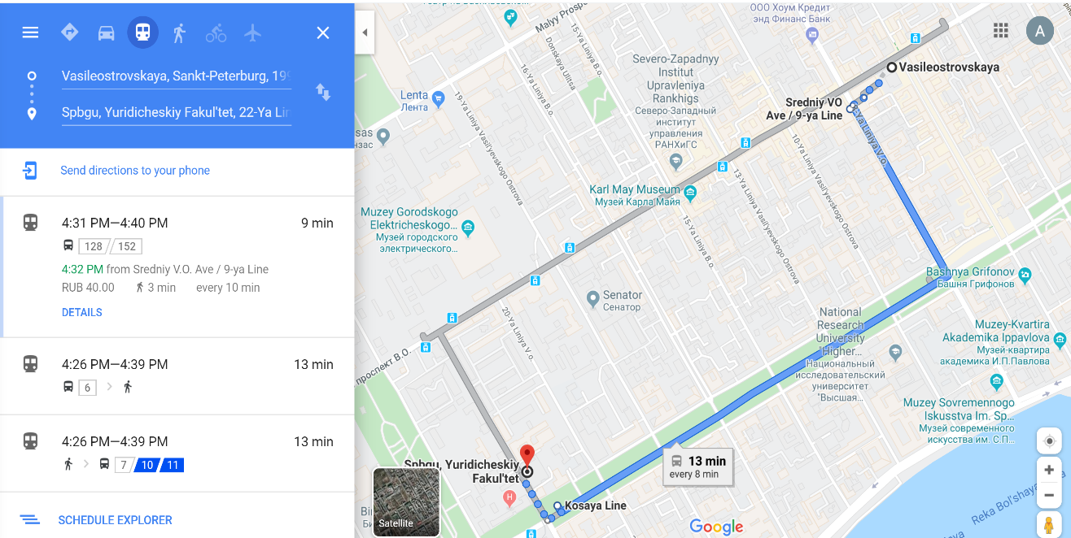

VII. Requirements for abstract’s design
- Not more than 20 000 characters long including spaces;
- Font – Times New Roman;
- Size – 14;
- Interval – 1,5;
- Margins – 20 mm (on all sides: top, bottom, left, right);
- Indent 0,7 cm, alignment justified;
- Page numbering – in the center;
- Footnotes (size) – 10;
- Keywords in English (5-7);
- Example of a document title: «Section 5. Ivanov. I. I.».
If the abstract’s design doesn’t meet the specified requirements, the Organizing Committee reserves the right to refuse to accept work.

Contact information
Official website: http://islaco.spbu.ru
E-mail: islaco@spbu.ru
Facebook: https://www.facebook.com/ISLaCo19/
Instagram: https://www.instagram.com/islaco_spbu/?igshid=s76b40azq51e
Contact number: +7 (981) 859-33-98 Anait
Appendix I. Example of the abstracts structure

Sources of constitutional law in the Russian Federation
3rd year student, 1 group
Saint Petersburg State University
Ivanov Ivan
Keywords: constitutional law
The main sources of constitutional law are...

Appendix II.
As part of the research on sport law, the conference participants may explore the following issues:
1. Possible ways to attract financing for transfer transactions: current trends and the possibility of their application under Russian legislation;
2. Transfer agreement and its qualification from the point of view of the Russia civil legislation;
3. Legal nature of sponsorship in the field of sport events;
4. Federal law on Advertising: does it meet the needs of the sports and entertainment market or constrain its development?
5. Pretrial settlement of labor disputes in the sport sphere;
6. Regional sports federations’ public control on organizations’ complying with federal standards of sport training;
7. The problems of ratio between Russian migration legislation and Labour Code in the sphere of legal relationships with foreign sportsmen;
8. The problems of legal enforcement of public order and public security during organization of official sport competition in Russia.
As part of the research on medical law, the conference participants may explore the following issues:
1. Realization of the constitutional right of citizens to health protection and medical help;
2. Protection of the rights and legitimate interests of medical workers;
3. Protection of the rights and legitimate interests of patients;
4. Legal problems of circulation of medicines within the Eurasian Economic Union;
5. The correlation of ethical and legal norms in the regulation of public relations in the field of medical care;
6. Legal regulation of reproductive technology;
7. Genomic research: legal and ethical issues.

